Linda Miao
Quiz 2:
-- This quiz has 7 questions. Please attempt all questions. Take screenshots of the query plan you get add an explanation
-- for each query plan. Put the screenshots of the query plans and the explanation in one PDF file and upload the PDF file

-- Please uncomment these lines in case you want to drop and recreate the QO_Fun_Quiz1
--USE master
--GO
--DROP DATABASE QO_Fun_Quiz1
--GO

CREATE DATABASE QO_Fun_Quiz1
GO

USE QO_Fun_Quiz1
GO

-- Creating 3 tables T1, T2, T3
CREATE TABLE T1
(
a int not null,
b int
)

CREATE TABLE T2
(
a int not null,
b int
)

CREATE TABLE T3
(
a int not null,
b int not null
)
GO

-- adding rows to the tables 1, T2 and T3
DECLARE @i1 int = 0
WHILE @i1 < 10000
BEGIN
SET @i1 = @i1 + 1
INSERT INTO T1 values(@i1, @i1*10)
END

DECLARE @i2 int = 0
WHILE @i2 < 30000
BEGIN
SET @i2 = @i2 + 1
INSERT INTO T2 values(@i2, @i2*10)
END

DECLARE @i3 int = 0
WHILE @i3 < 70000
BEGIN
SET @i3 = @i3 + 1
INSERT INTO T3 values(@i3, @i3*10)
END
GO

-- Please consider the following query for the following questions
SELECT *
FROM T1 JOIN T2 on T1.a = T2.a JOIN T3 on T1.a = T3.b

-- Q1
-- Q2
alter table T1 add CONSTRAINT T1_PK primary key (a)
Q1,No indexes: I ran the SELECT with no indexes on any table. The query plan showed Hash Match joins. This is because T1, T2, and T3 have no indexes and data is not sorted. The optimizer picked Hash Match because it works best for large unsorted tables. T1 is the smallest table (5,000 rows) so it was used as the build side to save memory.
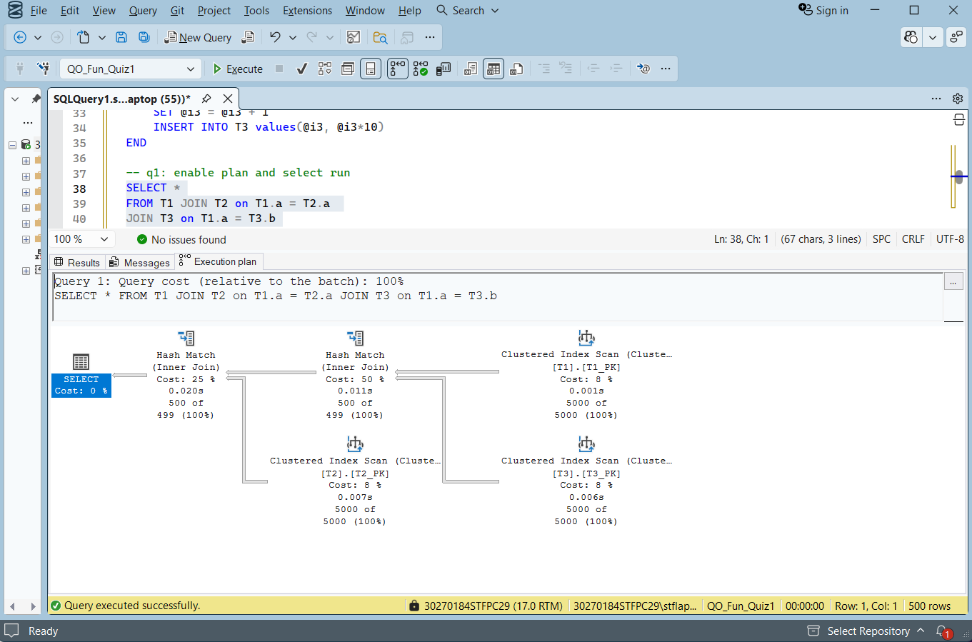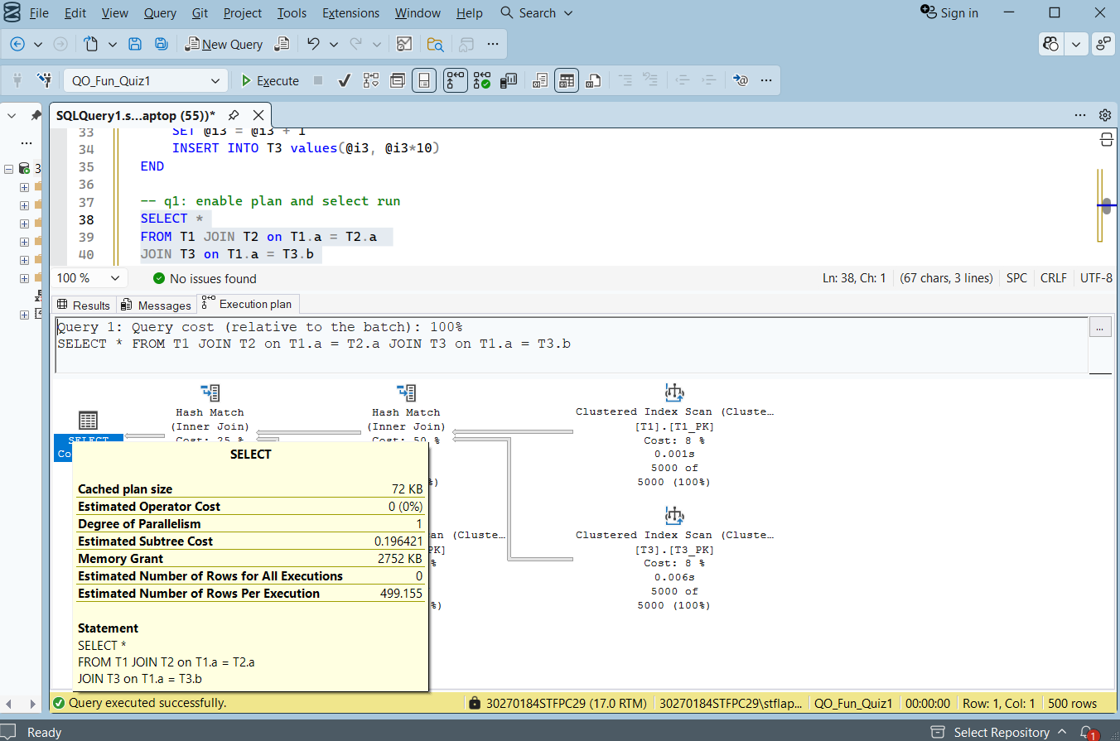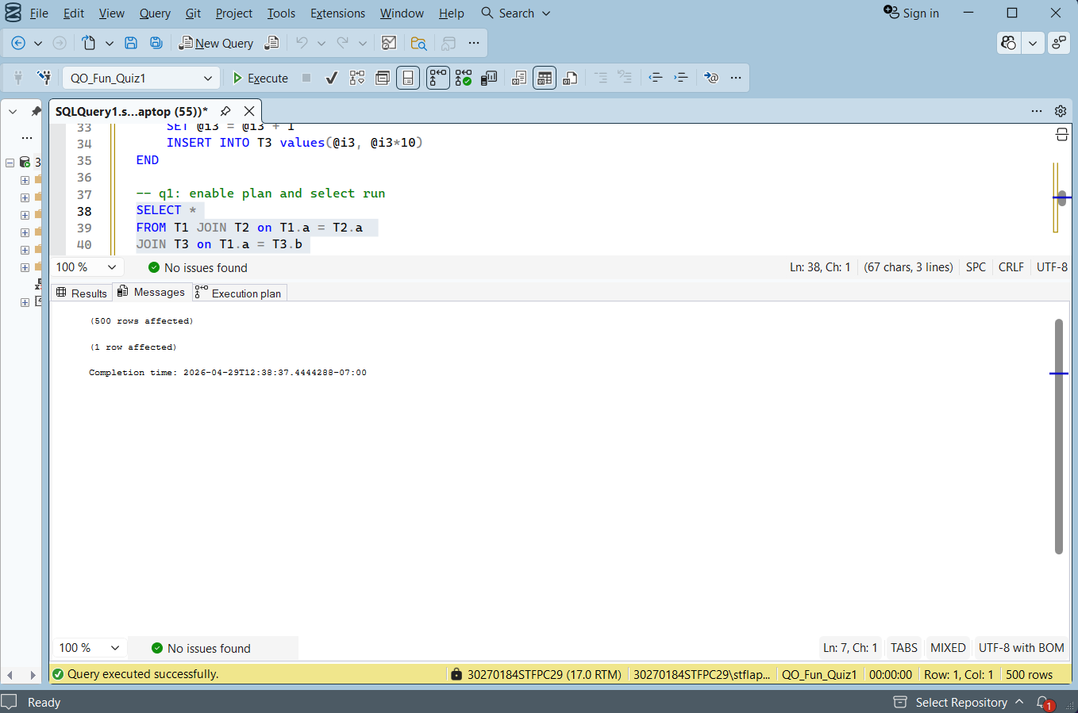

alter table T2 add CONSTRAINT T2_PK primary key (a)
Q2 , Clustered index on T1(a) and T2(a): After adding primary keys on T1(a) and T2(a), the query plan shows Hash Match joins with Clustered Index Scans on T1 and T2. With only 5,000 rows in each table, the optimizer chose Hash Match as the most cost efficient plan. The clustered indexes are visible as Clustered Index Scan operators in the plan.
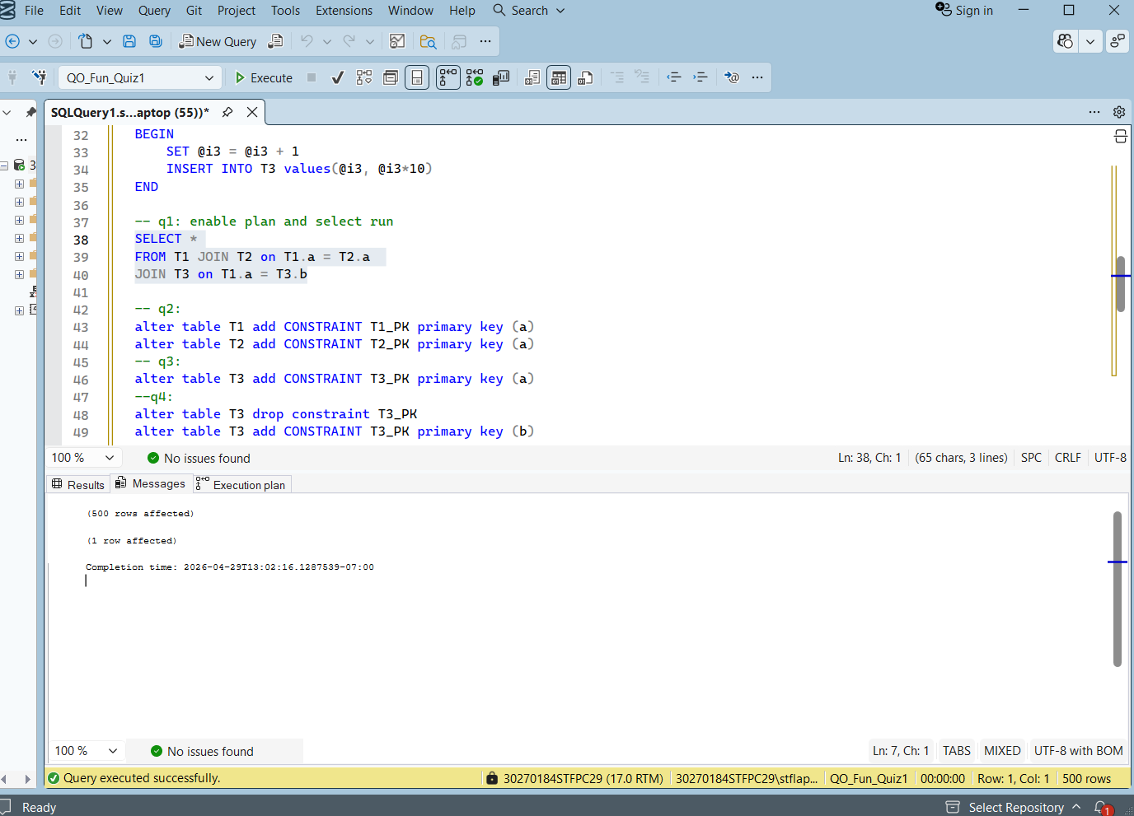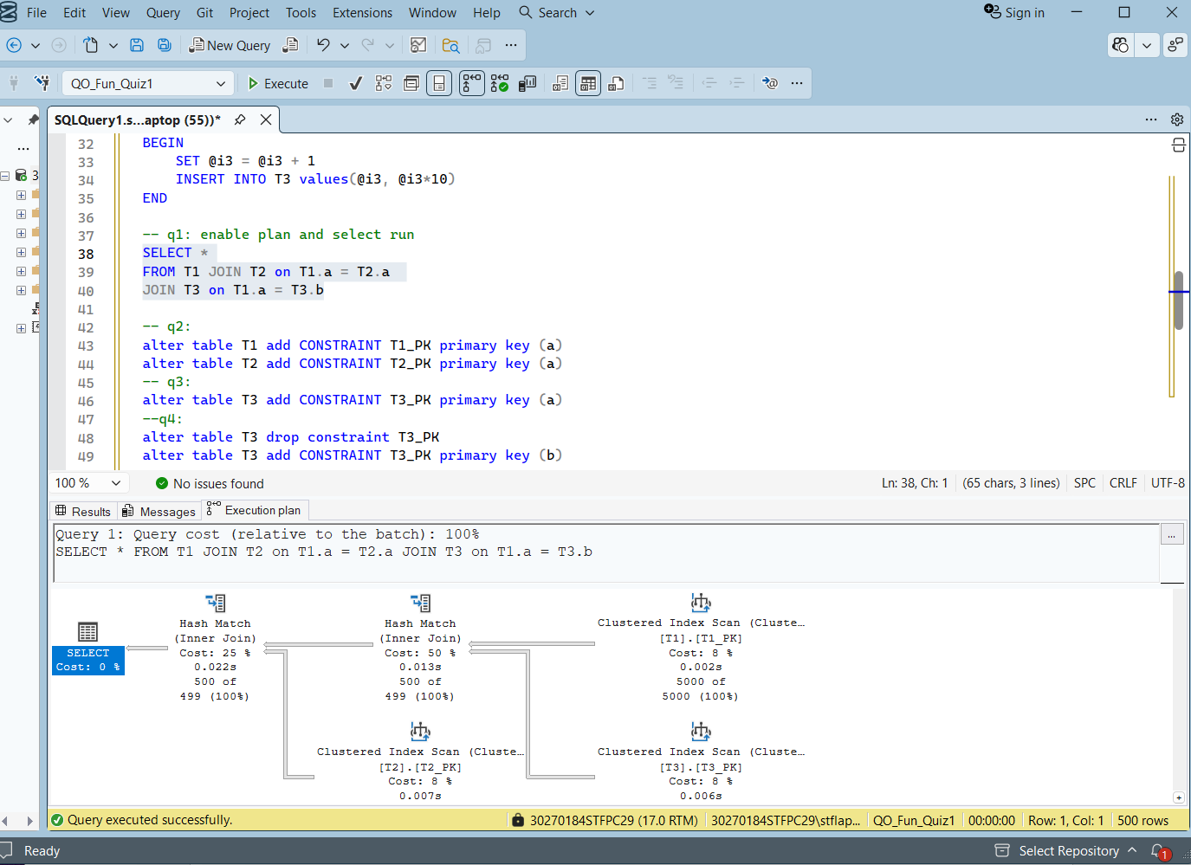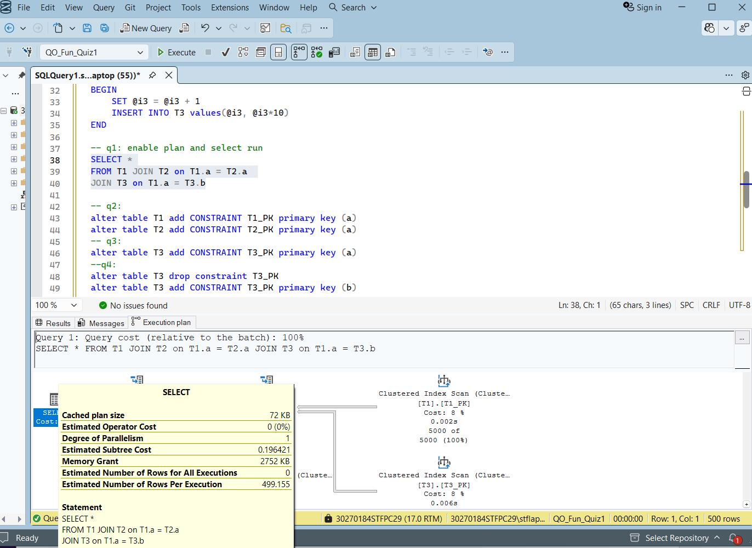
-- Q3
alter table T3 add CONSTRAINT T3_PK primary key (a)
Q3 Clustered index on T3(a): I added a clustered index on T3(a) but the query plan did not change. This is because the join condition uses T3.b, not T3.a. The index on a does not help when joining on b, so the optimizer ignored it and kept Hash Match for the T3 join.
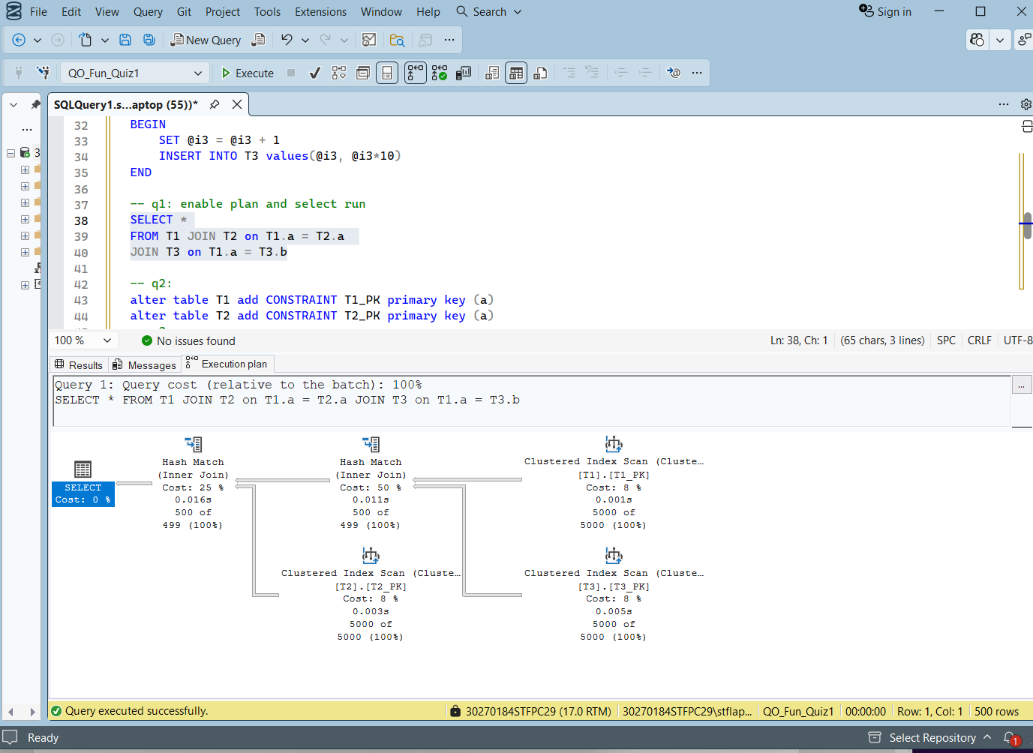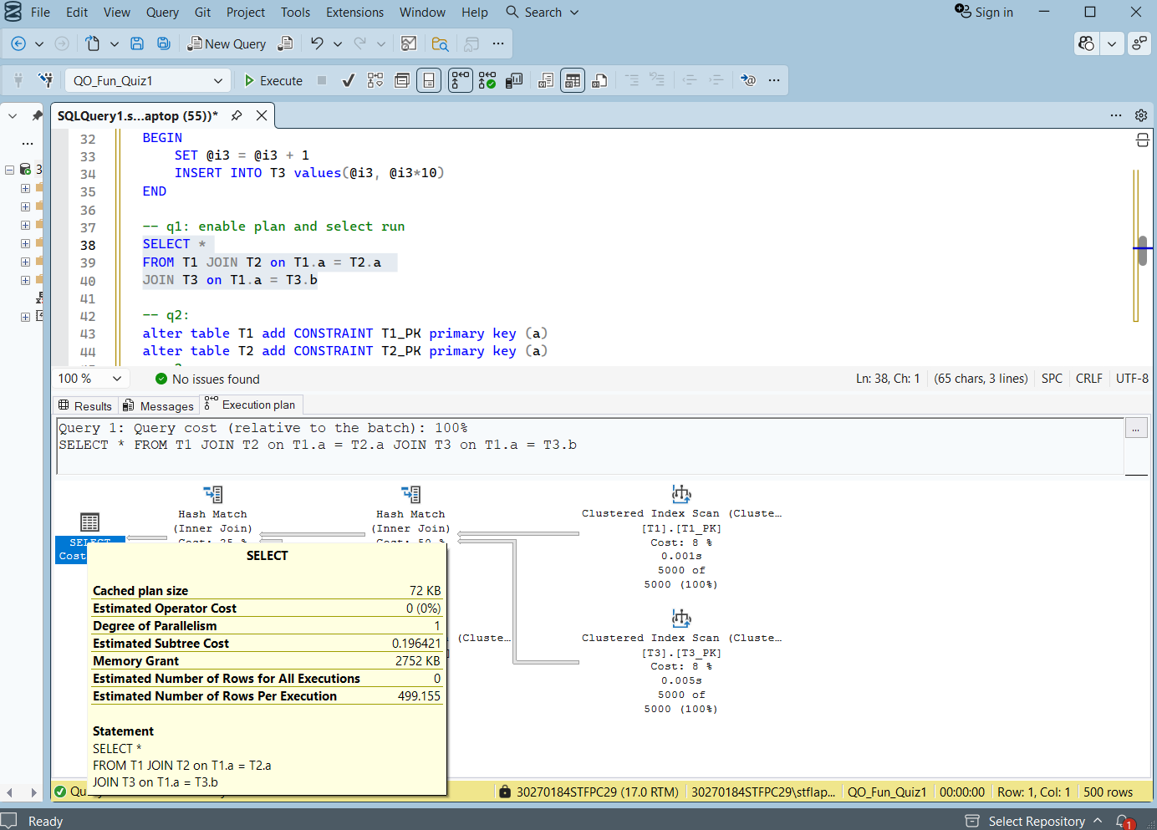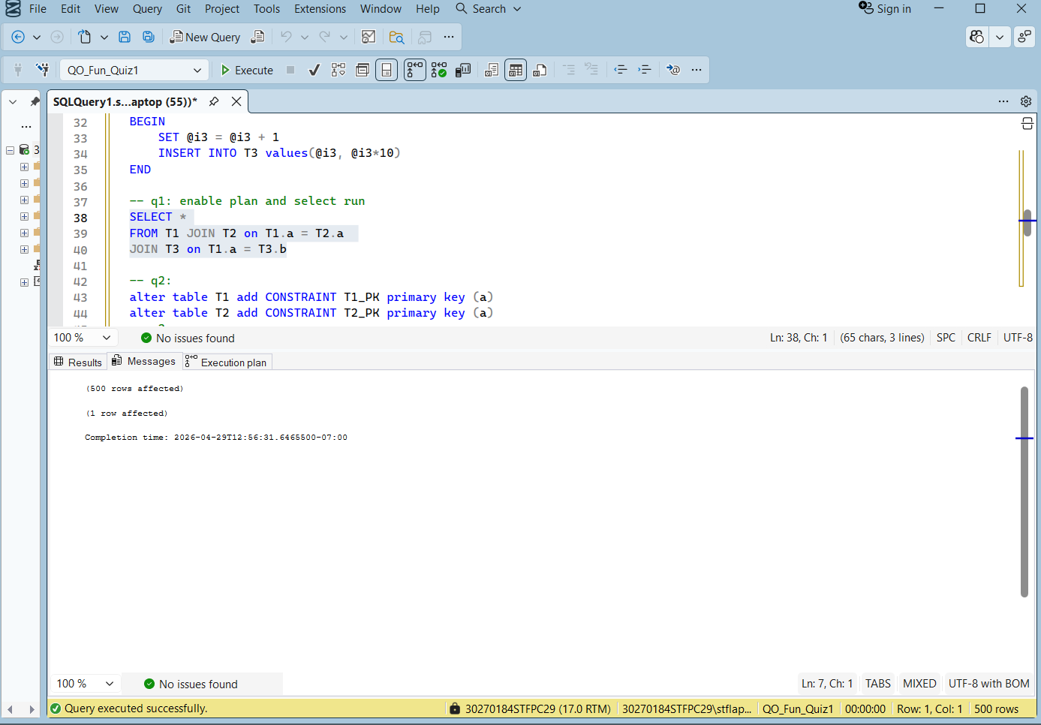
-- Q4
alter table T3 drop constraint T3_PK
alter table T3 add CONSTRAINT T3_PK primary key (b)
Q4 Clustered index on T3(b): After dropping T3(a) and creating the index on T3(b), all joins switched to Merge Join. Now T3 is sorted by b which matches the join condition T1.a = T3.b. Since all tables are sorted on their join columns the optimizer chose Merge Join for all joins.
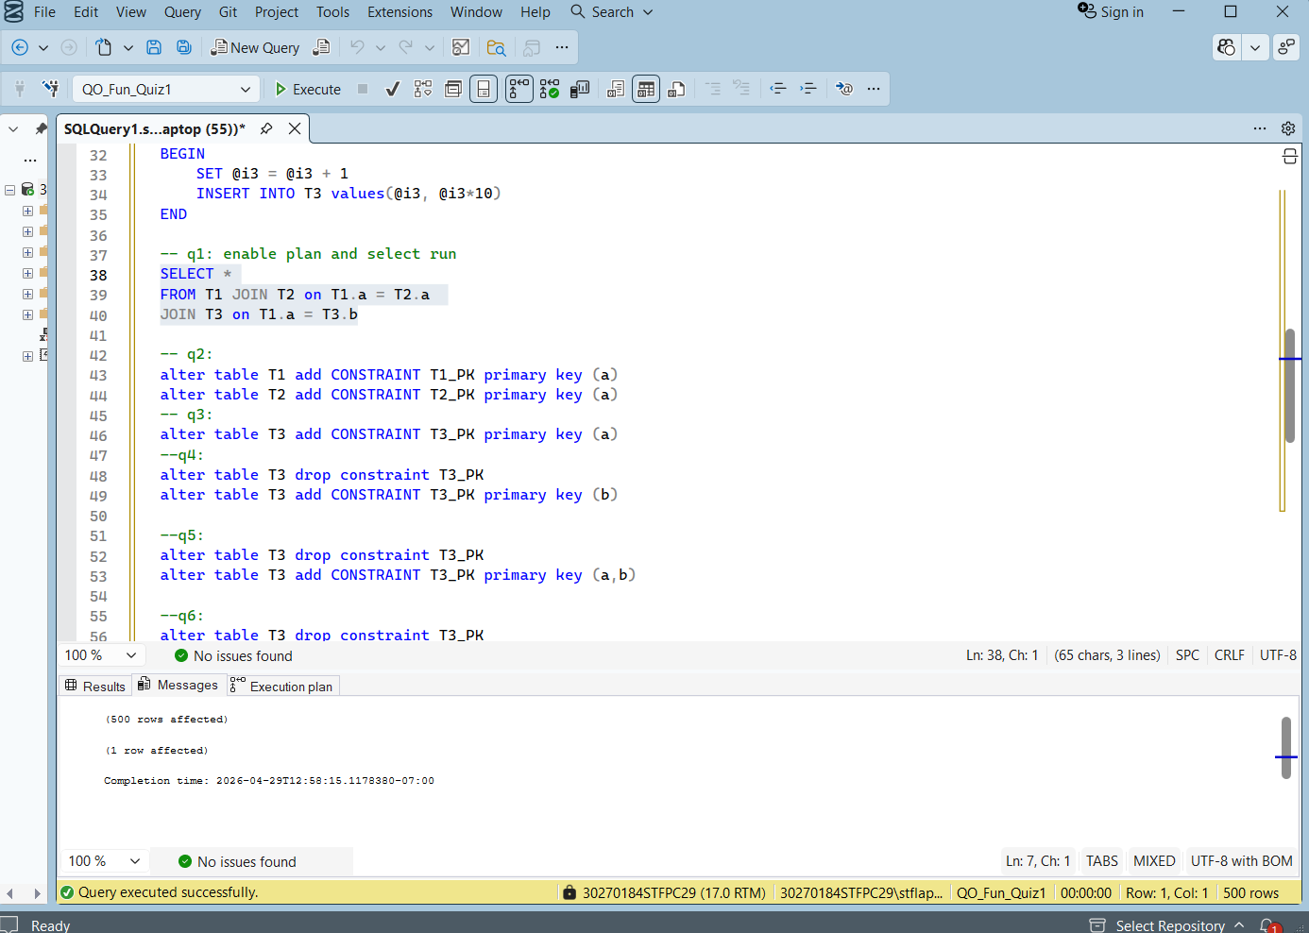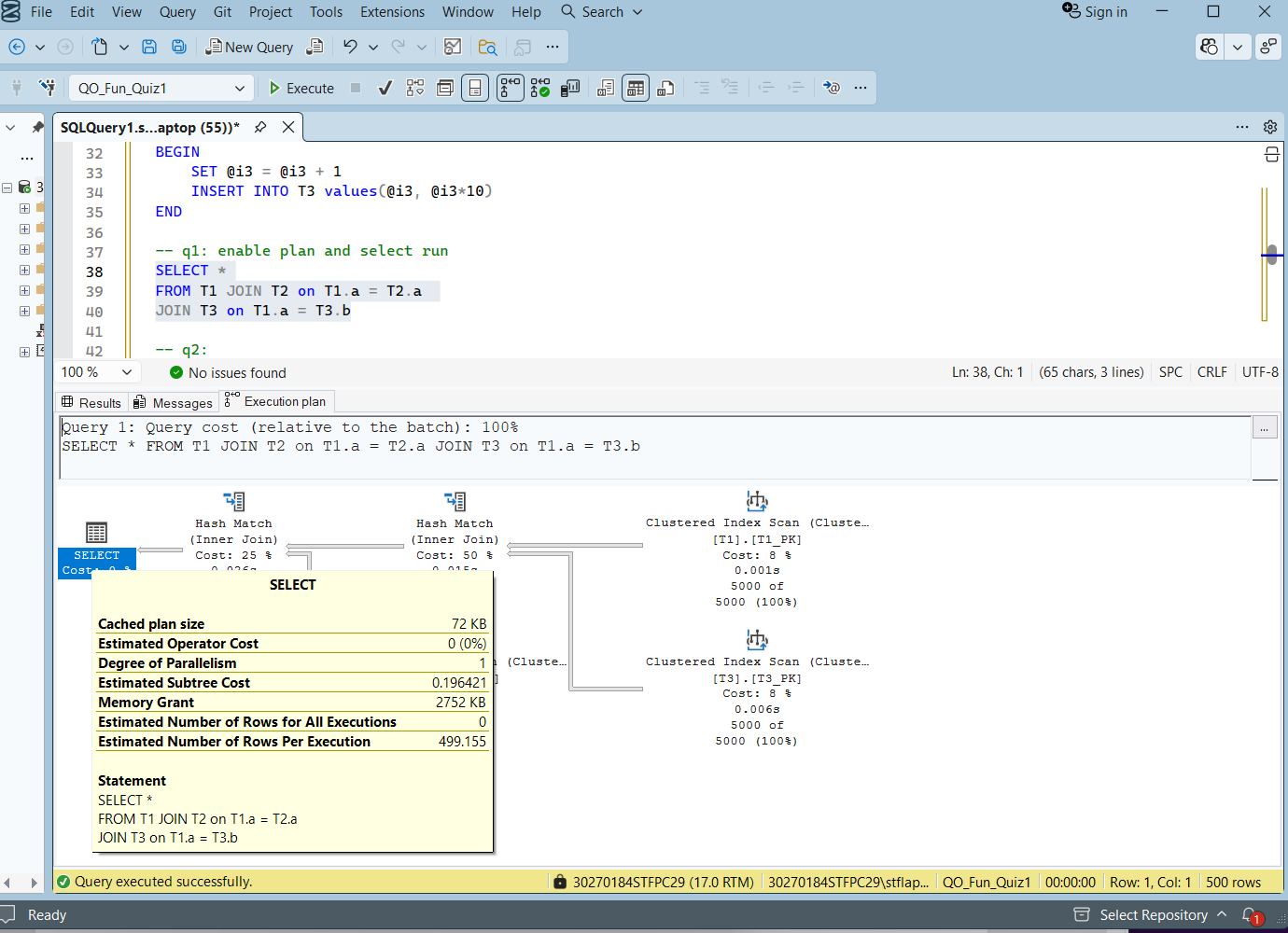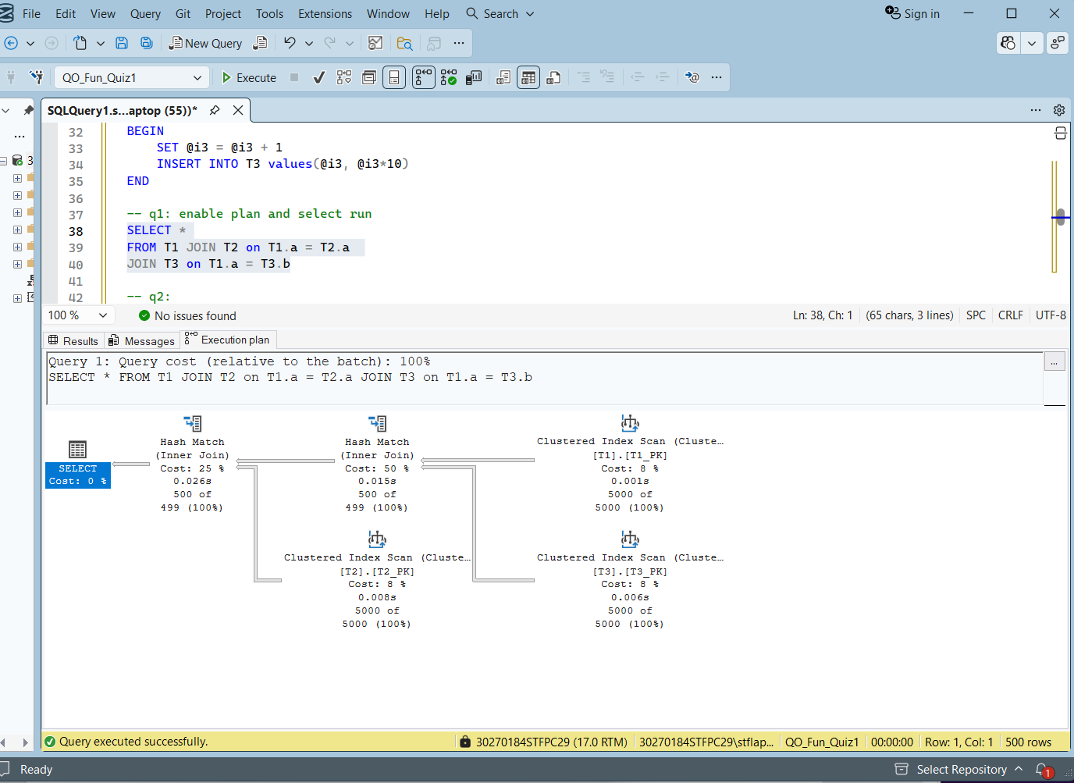

-- Q5
alter table T3 drop constraint T3_PK
alter table T3 add CONSTRAINT T3_PK primary key (a,b)
Q5 Clustered index on T3(a,b): After changing the index to (a,b), the plan reverted back to Hash Match for the T3 join. Even though b is in the index, a is the leading column so the data is sorted by a first. This means T3 is not globally sorted by b alone, so the optimizer cannot use Merge Join on b and switched back to Hash Match.
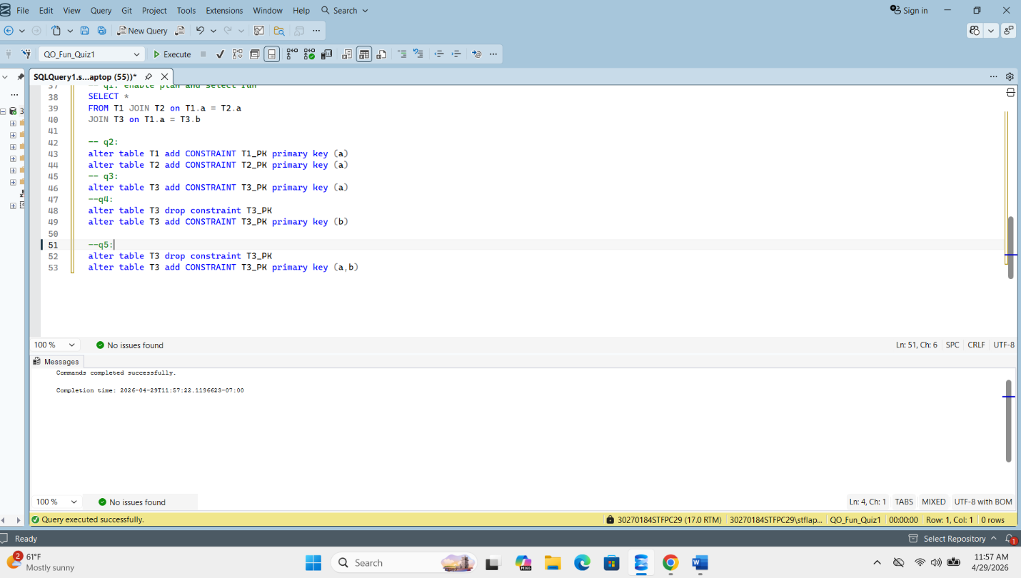
-- Q6
alter table T3 drop constraint T3_PK
alter table T3 add CONSTRAINT T3_PK primary key (b,a)
Q6 explanation: After creating index T3(b,a), the plan shows Hash Match. With 5,000 rows the optimizer chose Hash Match as the most cost efficient plan. T3 is sorted by b as the leading column which matches the join condition T1.a = T3.b.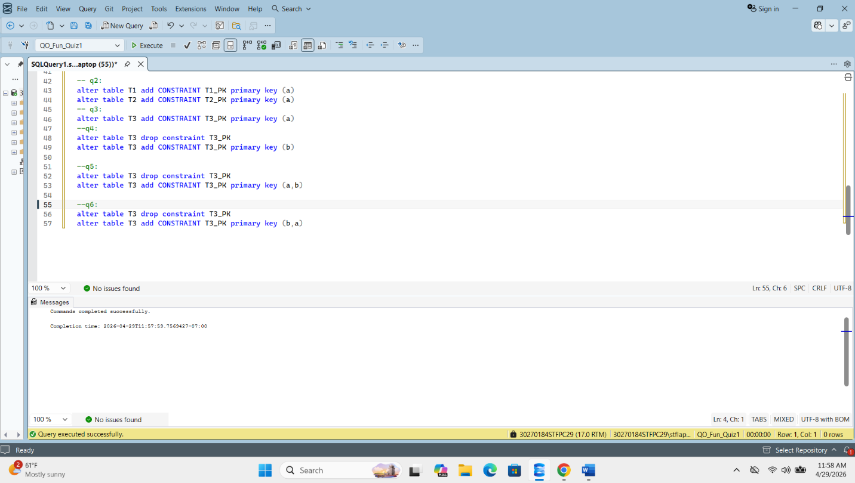
-- Q7
SELECT *
FROM T1 JOIN T2 on T1.a = T2.a JOIN T3 on T1.a = T3.b
Where T1.a>@param

Q7 — Different @param values:
- T1.a > 9999 — T1 returns 0 rows since all values are 1 to 5000. The optimizer chose Nested Loop because joining 0 rows costs almost nothing.
- T1.a > 0 — T1 returns all 5000 rows. The optimizer used Merge Join or Hash Match since all rows participate.
- T1.a > 2500 — T1 returns about half the rows. The optimizer may choose Nested Loop or Merge Join depending on the estimated row count and cost.
